Liverpool Irish Centre Membership Form
Membership Number
Thank you for supporting the Liverpool Irish Centre! Your membership enables us to continue as a vibrant community hub.
Go raibh maith agat
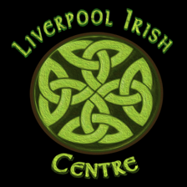
Name:

Address:

Phone No:

Email Add:

Male/Female/Other:

Type of Membership:
Adult £20 Family £30 (2 adults, 3 children)

Method of Payment: Cash / Card / Cheque / Paypal
(info@liverpoolirishcentre.org)

Date of Payment:

(date of payment will be used to determine membership expiry date)
Age Group (please tick one)
18-30
31-50
51-65
65+
Ethnicity (please tick one):
White British
White Irish
Irish Descent
White other
Other Irish
Irish Traveller
Gypsy/Traveller
Indian
White and black African
Other dual nationality
Other (please specify ________________________)

If a Family Membership, please complete the information for the Second Adult:

Name:

Email Address:

Age Group (please tick one)
18-30
31-50
51-65
65+

Ethnicity (please tick one):
White British
White Irish
Irish Descent
White other
Other Irish
Irish Traveller
Gypsy/Traveller
Indian
White and black African
Other dual nationality
Other (please specify ________________)

Your data will be stored in compliance with the General Data Protection Regulations. As part of this process you will be added to our mailing list. To opt out, please tick this box
How did you find out about our membership scheme?

